RETEST DATA SET

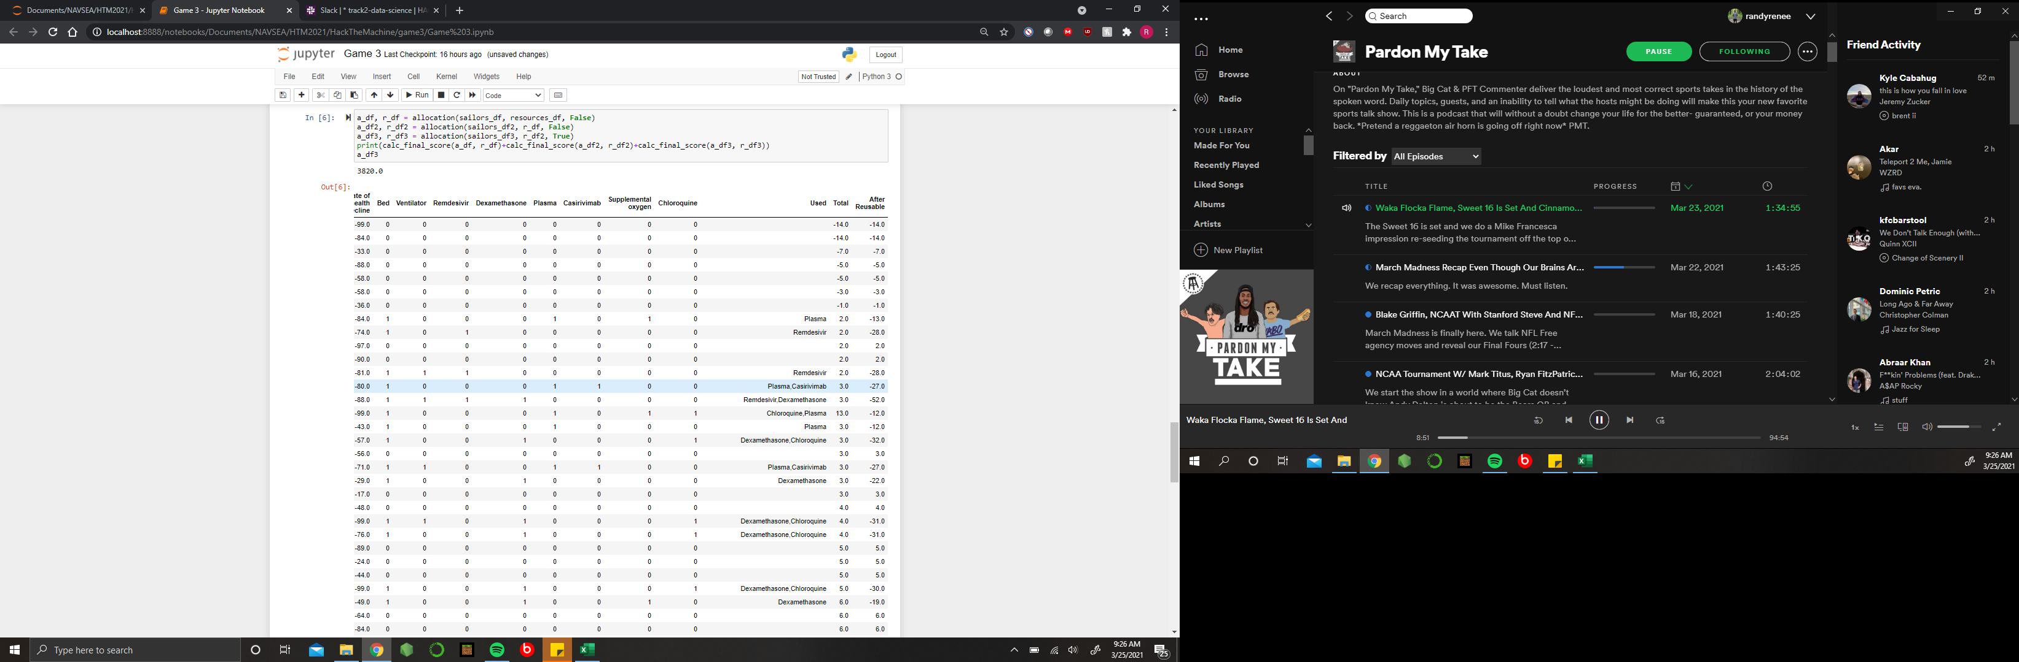

For our first set of retesting data we generated a completely random data set for each day given the same quantities of sailors with the range of health and health decline from 1 to 100 and -1 to -99, respectively. After running this test, we ended with a total overall score of 3820 and 7 casualties.

DANGER DATA SET

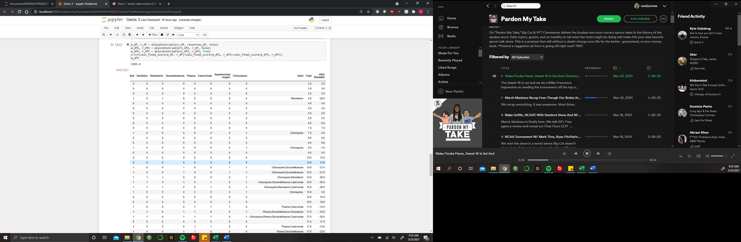

For our second set of testing data, we created a more “dangerous” situation. We decided to use the same quantities of sailors each day in order to make a more similar comparison. However, for this data we ranged the health of sailors from 1 to 75 and we ranged the health decline from -25 to -99. To our surprise, our overall score was 5365 and we ended with 0 deaths.